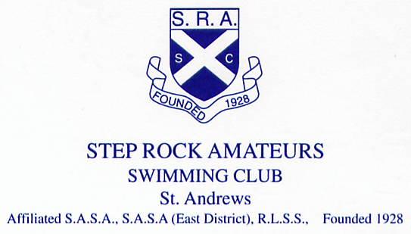

ANNUAL GENERAL MEETING

Agenda for Annual General Meeting to be held on Sunday 18th November 2018 at 6pm in St Andrews Bowling Club, Kinnessburn Road, St Andrews.

- Apologies

- Minutes of last AGM held on 12th November 2017

- President’s Remarks

- Treasurer’s Report

a. Annual statement of accounts
b. Membership Fee
c. Budget Proposal

- Coaches’ Reports

  - Learn to Swim
  - Junior Squad
  - Senior Squad

- Election of Office Bearers, Committee Members

- New Life Members

- Presentation of Trophies/Awards
  - Beginners Cup
  - Age Group Champion Trophies
  - Endeavour Trophy
  - Club Championship Records

- AOCB

